**­­­**

Class 7

**Lecture 15**

**HTML**

**HTML Basic**

**HTML**



**Lab Objectives:**

* HTML Heading.
* HTML Editor.
* Text Formatting.

**HTML Heading**

Headings are defined with the <h1> to <h6> tags. <h1> defines the most important heading. <h6> defines the least important heading.

<h1>Heading 1</h1>

<h2>Heading 2</h2>

<h3>Heading 3</h3>

<h4>Heading 4</h4>

<h5>Heading 5</h5>

<h6>Heading 6</h6>

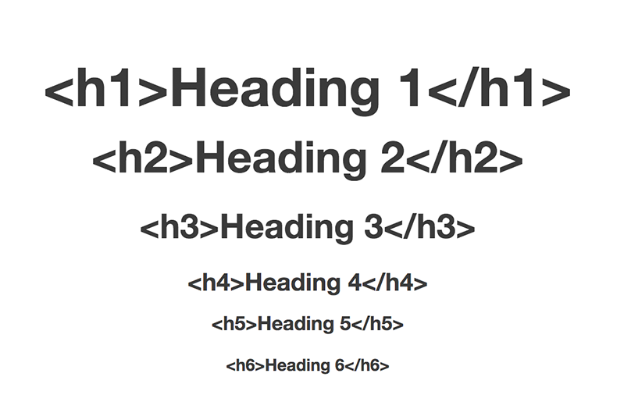

**HTML Paragraph.**

The HTML <p> element defines a paragraph:

<p>This is a paragraph.</p>

<p>This is another paragraph.</p>

**HTML Text Formatting Elements**

HTML uses elements like <b> and <i> for formatting output, like bold or italic text. Formatting elements were designed to display special types of text:

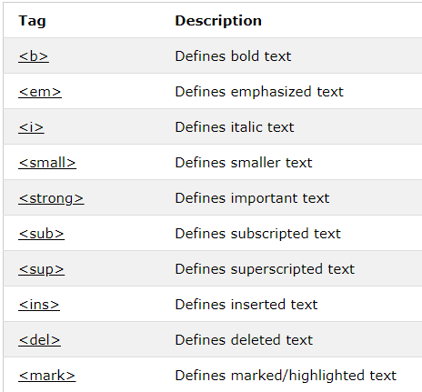

<b>This text is bold</b>

<i>This text is italic</i>

**Text Formatting Demo**

